BMP to ICVGM303

Tools needed :

  - ICVGM303
  - BMP2PP
  - Blitz3D demo version
  - ConvertPixelV3.0.bb (My Blitz3D conversion program)

Tools that may help :

  - Image ripper
  - Paint.net or other graphics tools.

Step 1 : Install Blitz3D demo version

Step 2 : Make a cool picture to convert

For example, i've taken this original picture from Bomliss on NES.

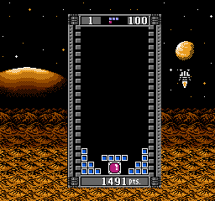
I've extracted the part i want to insert in my game, and made another .BMP file with Paint.net. We've got that :


This new picture must be resolution : 240x160 for the batch conversion tool.

Step 3 : Use BMP2PP to reduce the number of color.

Open BMP2PP and configure it like the picture below :

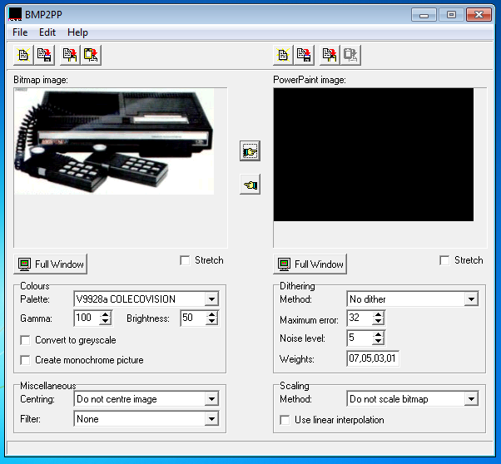

Now in the left, open your BMP File.

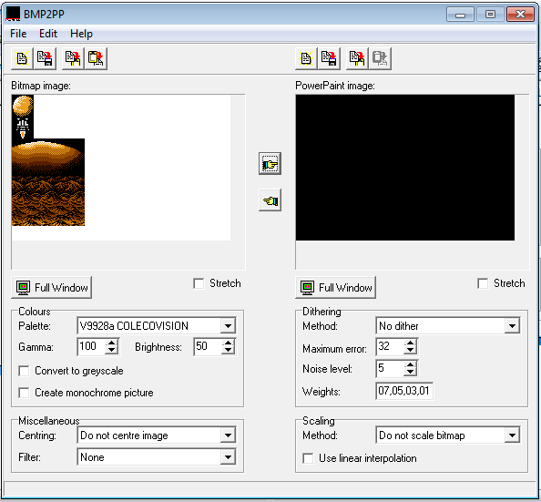
Click on the hand to the right.

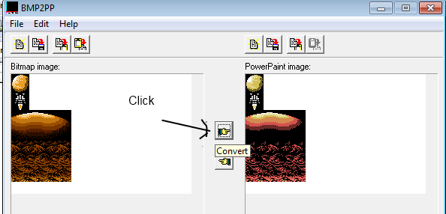

Then to the Hand on the left to copy the PowerPaint reduced color picture into the BMP picture.

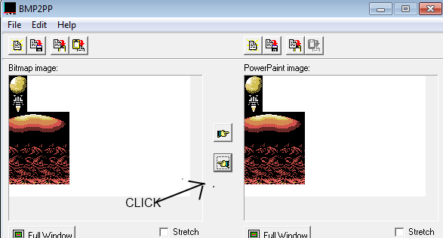
Now resave your BMP file.

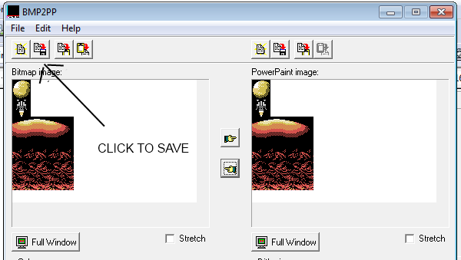

Step 4 : Open Blitz3D Demo

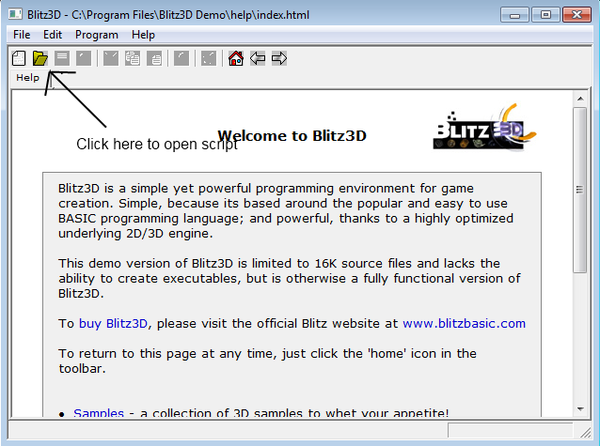
Open the script : ConvertPixelV3.0.bb

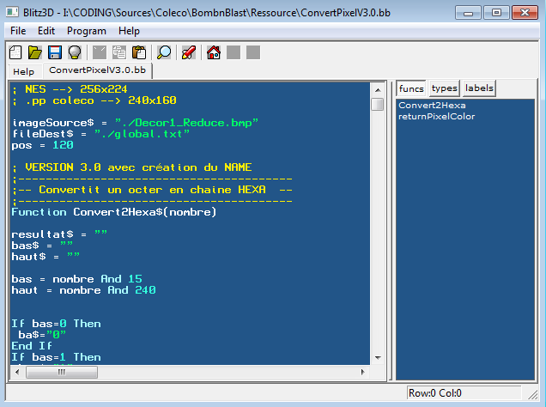

There's 3 parameters to change :

imageSource$ = "./Decor1_Reduce.bmp" --> The name and path of the last BMP you saved
If you're not sure what you do, put the full path of the file

fileDest$ = "./global.txt" --> The text file who will be generated

pos = 120 --> at wich position in ICVGM will the tile be generated ? Here i've take 120 after the font character and my explosition caracters for example.

After configuring that, press F5 to launch the script.

The global.txt file will be generated

Step 5 : The most complicated part.

Open ICVGM303.exe and in our example we will use a blank .dat file.

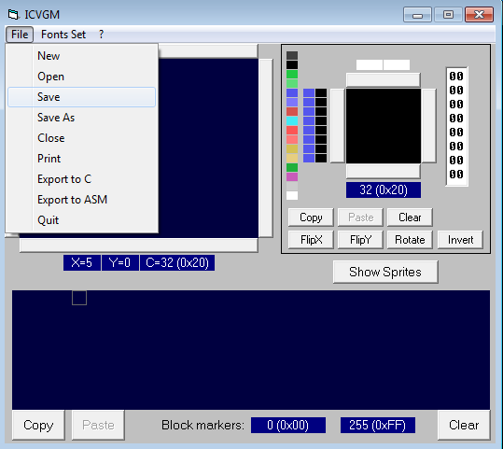
Now, what is our blank.dat file ? It's a text file !

Look :

NAME DB $20,$20,$20,$20,$20,$20,$20,$20,$20,$20,$20,$20,$20,$20,$20,$20
DB $20,$20,$20,$20,$20,$20,$20,$20,$20,$20,$20,$20,$20,$20,$20,$20
[...]
PATTERN DB $FF,$FF,$E2,$C0,$80,$D5,$F7,$C4,$C0,$C0,$C0,$FE,$D8,$FF,$C0,$C0
DB $FF,$FF,$FE,$FC,$F4,$E0,$F0,$F5,$E0,$82,$81,$80,$80,$C1,$C0,$E5
[...]
MCOLOR DB $10,$10,$16,$18,$16,$6E,$6F,$6E,$16,$18,$19,$68,$89,$60,$18,$16
DB $10,$10,$16,$16,$16,$16,$18,$19,$18,$16,$18,$18,$18,$18,$16,$16
[...]
SPATT DB $00,$00,$00,$00,$00,$00,$00,$00,$00,$00,$00,$00,$00,$00,$00,$00
DB $00,$00,$00,$00,$00,$00,$00,$00,$00,$00,$00,$00,$00,$00,$00,$00
[...]
SCOLOR DB $0F,$0F,$0F,$0F,$0F,$0F,$0F,$0F,$0F,$0F,$0F,$0F,$0F,$0F,$0F,$0F
DB $0F,$0F,$0F,$0F,$0F,$0F,$0F,$0F,$0F,$0F,$0F,$0F,$0F,$0F,$0F,$0F

And what there is in our global.txt file ?? THE SAME THING. With more shit due to Blitz3d ...
So, with a text editor, copy the NAME,PATTERN,MCOLOR section from global.txt to blank.dat.
(Donc copy the last DB from each section of the global.txt ! I must improve the script).

Step 6 : Open blank.dat

Et voilà !!

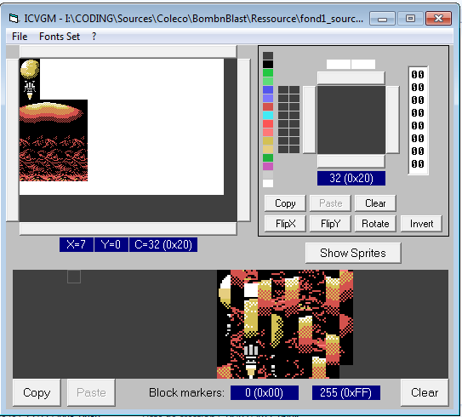
Step 7 : Improve the batch !

Yes, it's coded with feet in 4 hours, so the code is absolutly afwull, but it works. Feel free to improve it or modify it !!

Have fun !!

